**Tutorial 6: Outputting lists (v-for)**

We will be looking at how to output an array of data that can be outputted and creating a button that will hide and show the information. We will be looking at outputting information related to South African musicians.

Make sure **Tutorial 5** is complete to be able to move on to this tutorial or clone the [vue3-firebase-course](https://github.com/younggrasshopperza/vue3-firebase-course) repository and go to branch called **Tutorial-5**.

In the **index.html** file, make sure the code looks like the below:

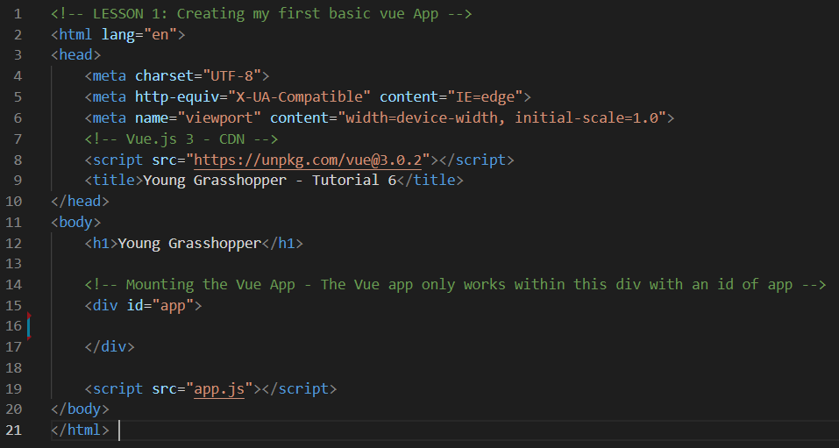

In the **app.js** file, make sure the code looks like the below:

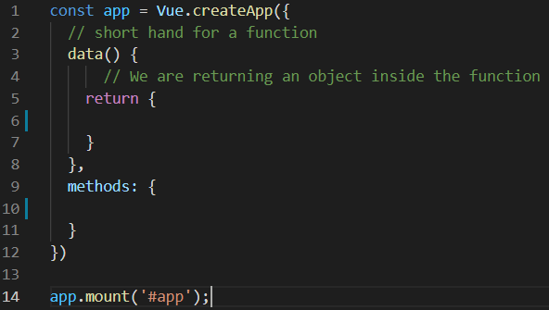

**Step 1:** In the **app.js** file, firstly create a **Boolean** data property called **showDiscography** that is set to true.

Secondly create an **array of objects** called discographies, each object should have a **key-value pair** with the keys, **artist**, **album** and **genre**.

Lastly create a function called **toggleShowDiscography** that changes the **showDiscography** data property to the opposite **Boolean** when the function is called.

Look at the example below (**Line 6 to 23 and line 27 to 29**):

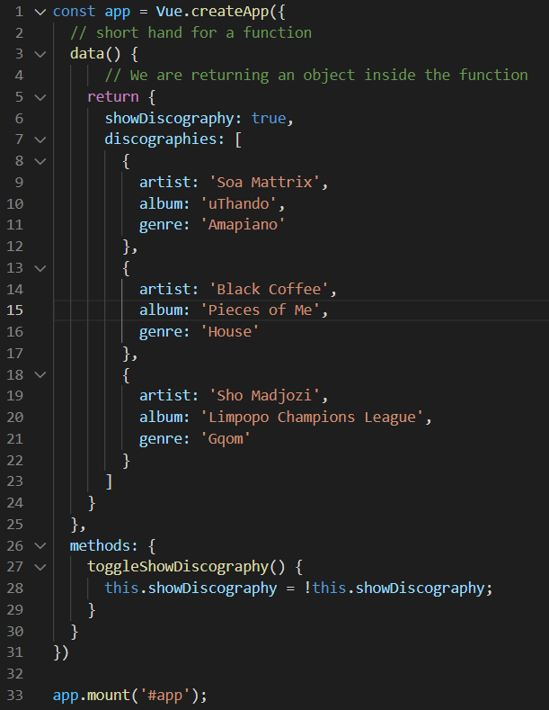

**Step 2:** In the **index.html** file, create a div tag with a **v-if** condition that takes the **showDiscography** data property. Inside the **div** tag create an **unordered** **list**.

The list should include a **v-for** that loops through the discographies **array** and output the data into separate **span** tags.

Create a **button** with a **click event** that takes the **toggleShowDiscography** function. Inside the button should have a span that has a condition to display the text Hide Discography or Show Discography when the button is clicked.

Look at the example below (**Line 17 to 33**):

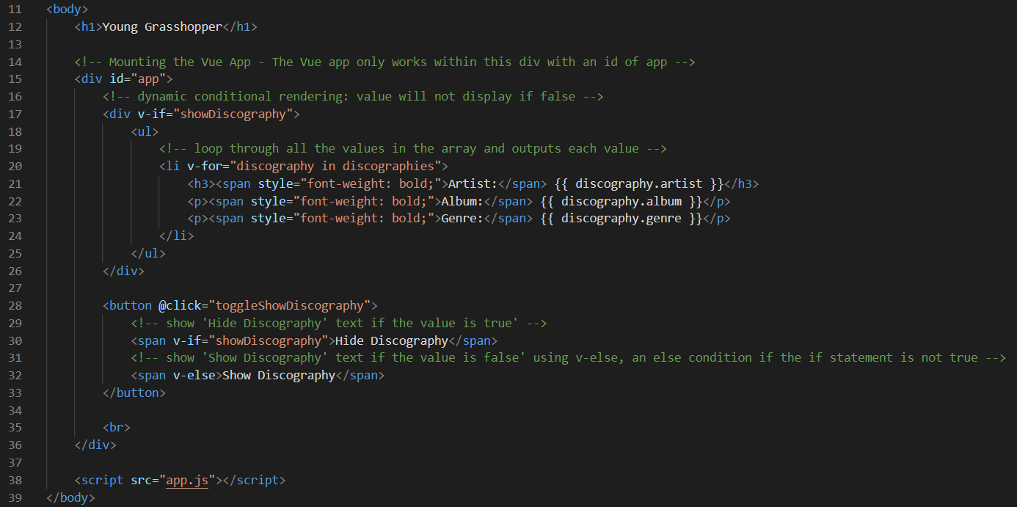

discography allows us to access each individual object that is being outputted from the discographies array.

v-for="discography in discographies"

**Output:**

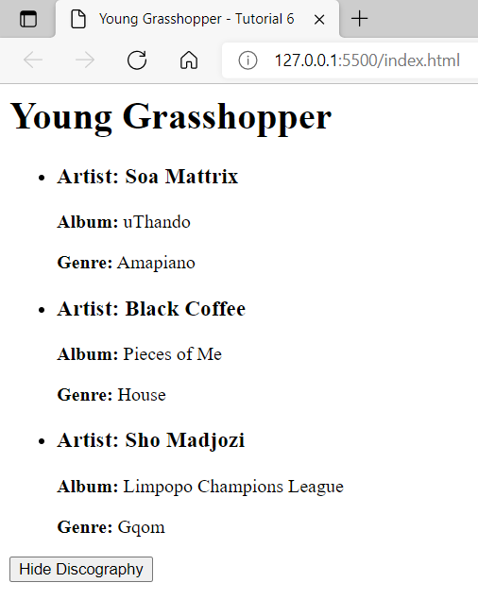

Additional Resources can be found in the [vuejs.org](https://v3.vuejs.org/) website under the [conditionals and loop](https://v3.vuejs.org/guide/introduction.html#conditionals-and-loops) section.

**You can view the code snippets from the** [**vue3-firebase-course**](https://github.com/younggrasshopperza/vue3-firebase-course) **repository under the Tutorial-6 branch.**